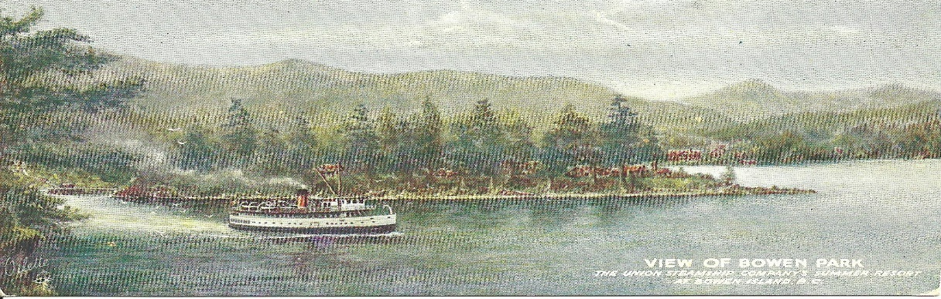
Bowen Island Beaver Day Trip
Date: Saturday, May 14th
Time: 9:15am – 3:30pm
Cost: $10.00 Register by: April 27th
The Beavers next adventure will be taking the ferry over to Bowen Island and spending the day exploring Crippen Park and having a little beach time amongst other activities along the way.
This is not a Family event as there are three different Burnaby groups going, 1st Centre Lake, 1st Southwest, and 76th Burnaby and BC Ferries will only allow us so many to reserve. We will be taking a long a couple of parent helpers to assist along the way but not too many.
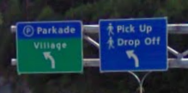
How this will work:
- Each group is going to try and arrange a little car-pooling to and from Burnaby out to Horseshoe Bay. Following the Ferry Passenger Drop Off signs into Horseshoe Bay there is a pay parking lot on Keith Road. As you can see in the picture below there is a blue sign at the entrance of the parking lot and if you drive 1 block further as the sign indicates the Drop Off will be on your right.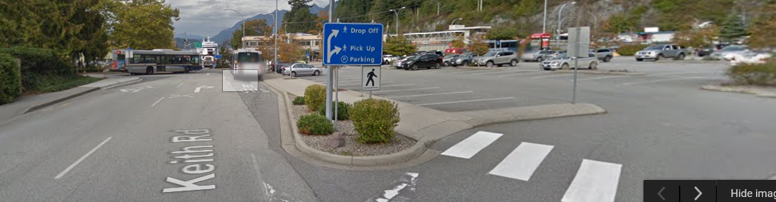
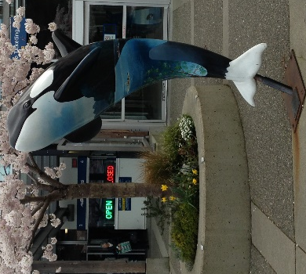
- For those that have travelled through Horseshoe Bay before there is a limited amount of expensive parking. However there are handy passenger Drop Off zones that allow you to park for 3 minutes right beside where we are all meeting up.
- Our meeting spot is the whale out front of the ticket booth, see picture
- Beavers needs to be on time as the ferry won’t wait for us. Leaders will be there starting at 9am and will take the kids upstairs at exactly 9:30am. They will then walk on to the 10am ferry.
- Beavers need to bring a little backpack with a water bottle, lunch, and if it is required extra clothing for the weather. Beavers should be dressed weather appropriate as we will be outside all day, including their uniforms.
- A morning and afternoon snack will be provided. We will not be purchasing anything on the ferry.
- The Beavers will return on the 3pm ferry.
- There are 3 pay parking lots right by the passenger drop-off for those parents that would like to get to Horseshoe Bay a little early for either sailing. Keep in mind they do check that you have paid.
- For parents that are volunteering as parent helpers there is the option to park and ride. Some of the leaders will be parking in West Van and taking the bus into Horseshoe Bay to save the all-day parking fee. Please advise if you require information on this option.

