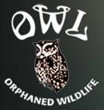
OWL Orphaned Wildlife Rescue Visit
3800 72nd Street, Delta, BC V4C 6J3

Directions using the Starting Point of the Big Bend/Market Crossing Shopping Complex on Marine Way E in South Burnaby
*Estimated driving time 35 minutes*

1. Head EAST on Marine Way E towards the Queensborough Bridge
2. Use the far LEFT lane to take the BC 91A S ramp to Richmond/Delta
3. Continue onto the Queensborough Bridge
4. Keep LEFT at the fork, follow signs for BC-91 S Alex Fraser Bridge Delta/Surrey
5. Keep LEFT and merge onto the Alex Fraser Bridge
6. Take Exit 4 for 64th Avenue W
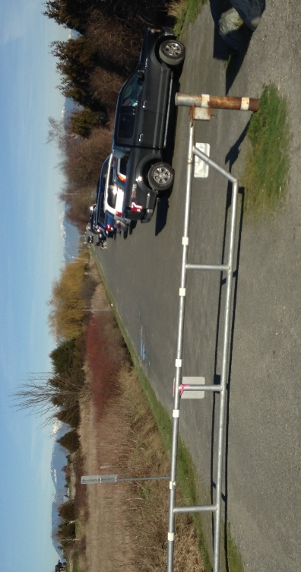
7. Merge to the RIGHT onto 64th Ave/Kittson Parkway
8. 64th Ave/Kittson Parkway turns slightly left and becomes 104 St
9. Turn RIGHT onto Ladner Trunk Road
10. Turn LEFT onto 72 St, there is a light at this intersection.

*11A. If heading for the Dyke first, drive across the train tracks all the way to the very end of 72 St and park. The picture shows the gate and the parking at the end of 72nd.

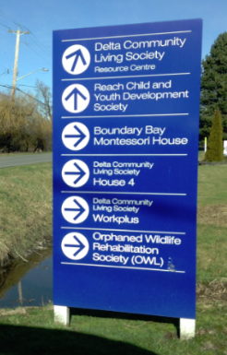
*11B. If heading for the OWL Rescue Centre, drive across the train tracks and look for this sign that will appear on your LEFT and turn LEFT into the driveway behind it.
Note this sign can be read from both directions so you can find your way to the OWL facility after the Dyke as well.

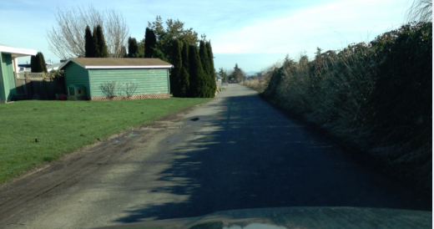
This is a long driveway and several other businesses on it so follow it all the way until the end, see picture below. OWL is at the very end with parking to your left.

